**Lemon and Rosemary Curd**

Unusual but good. Would make a different filling for a Victoria sponge or is also good on toast!

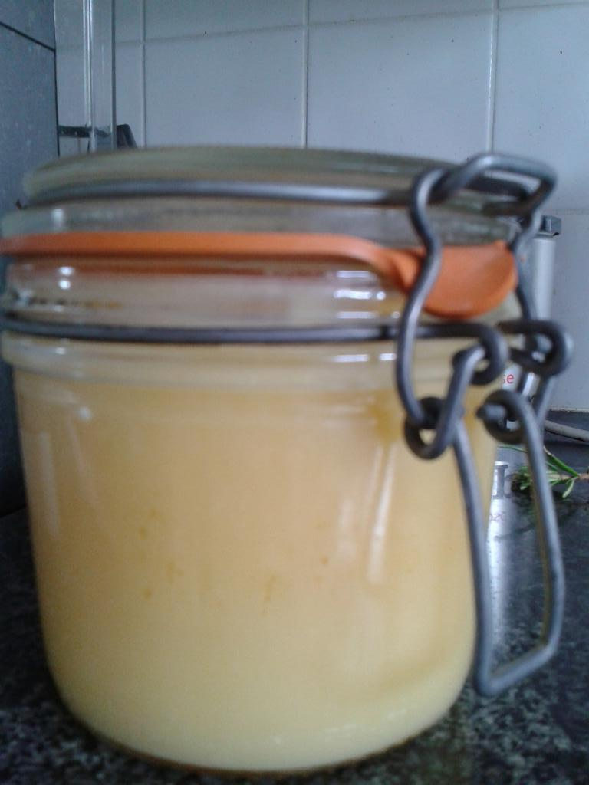

**Ingredients:**

4 Unwaxed Lemons

200g Caster Sugar

100g Butter

4 Eggs and 1 egg yolk

5 Stalks of Rosemary

**Method**

1. Zest and juice the lemons and put into a heatproof bowl along with 2 teaspoons of finely chopped rosemary, the sugar and the butter. Heat over a saucepan of simmering water (the water should not touch the bottom of the bowl) until the butter is melted, keep the bowl on the saucepan and the heat on for the following steps. Then add the remaining sprigs of rosemary
2. Whisk the eggs and yolk together then quickly mix into the lemon mix, it might look odd to start with but keep mixing and it will come together.
3. Keep stirring until the mixture thickens until almost a custard texture then remove from the heat.
4. Sieve and put in sterilised jars, refrigerate when cool.